Abstracts need to be in one-page, within 400 words maximum
Title in bold letters, names of authors, affiliation, text, figure (if any) and the references. The presenting author’s name is underlined and bold.
The following example from the 2024 OTS meeting is shown
Please use this as example of templates submit as a word document.
Example template
RNA interference through single-stranded hairpin loop RNAs (loopmeRNAs)
Dhrubajyoti Datta,¹ Krishna C. Aluri,¹ Scott Waldron,¹ Nate Taneja,¹ June Qin,¹ Daniel P. Donnelly,¹ Christopher S. Theile,¹ Dale C. Guenther,¹ Li Lei,² Joel M. Harp,² Pradeep S. Pallan,² Martin Egli,² Ivan Zlatev,¹ and Muthiah Manoharan¹
¹Alnylam Pharmaceuticals, 675 West Kendall Street, Cambridge, MA 02142, USA
²Department of Biochemistry, Vanderbilt University, School of Medicine Nashville, TN 37232, USA

Synthetic small interfering RNAs conjugated to trivalent N-acetylgalactosamine (GalNAc) have been clinically validated for gene silencing in liver hepatocytes. Incorporation of phosphorothioate linkages and ribose modifications are necessary for stability, potency, and duration of pharmacology. With the goal of simplifying synthesis and purification, we designed GalNAc ligand-containing single-stranded loop hairpin RNAs (loopmeRNAs). The loopmeRNAs¹ are synthesized as a single strand containing relevant chemical modifications. We expected that cleavage in the loop, mediated by non-specific nucleases, would release a mature siRNA. We evaluated in vivo pharmacology and in vitro metabolism of various loopmeRNA designs with the goal of identifying a loop composition optimal for efficacy. Our studies demonstrate that loopmeRNAs efficiently silence expression of target genes with comparable efficacy to double-stranded siRNAs. The loopmeRNA design streamlines the siRNA manufacturing process, reducing the environmental and regulatory burdens.

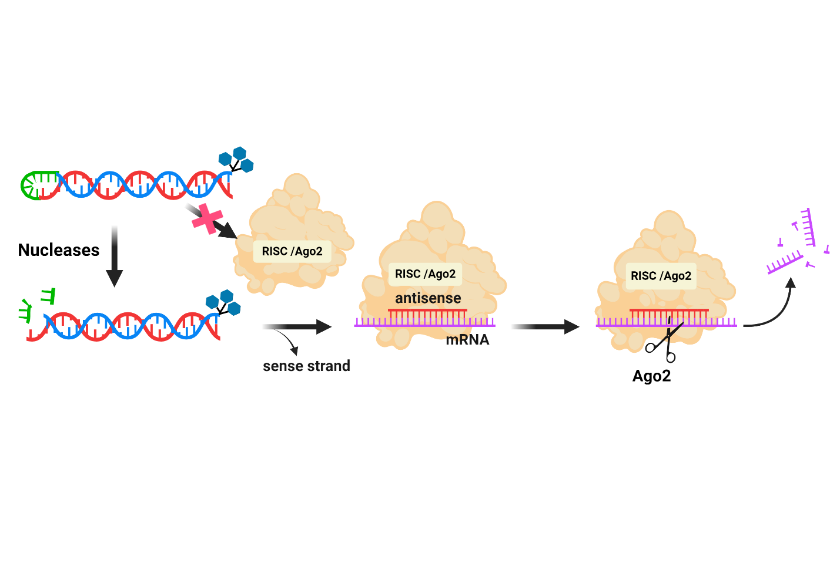
Reference

¹ Aluri, K.C; Datta, D. et al., J. Am. Chem. Soc. 2024, 146, 28161–28173.

